**Module 3: SQL REPORT**

**Database Schema Design:**

**ERD Diagram for Customer Churn Prediction:**

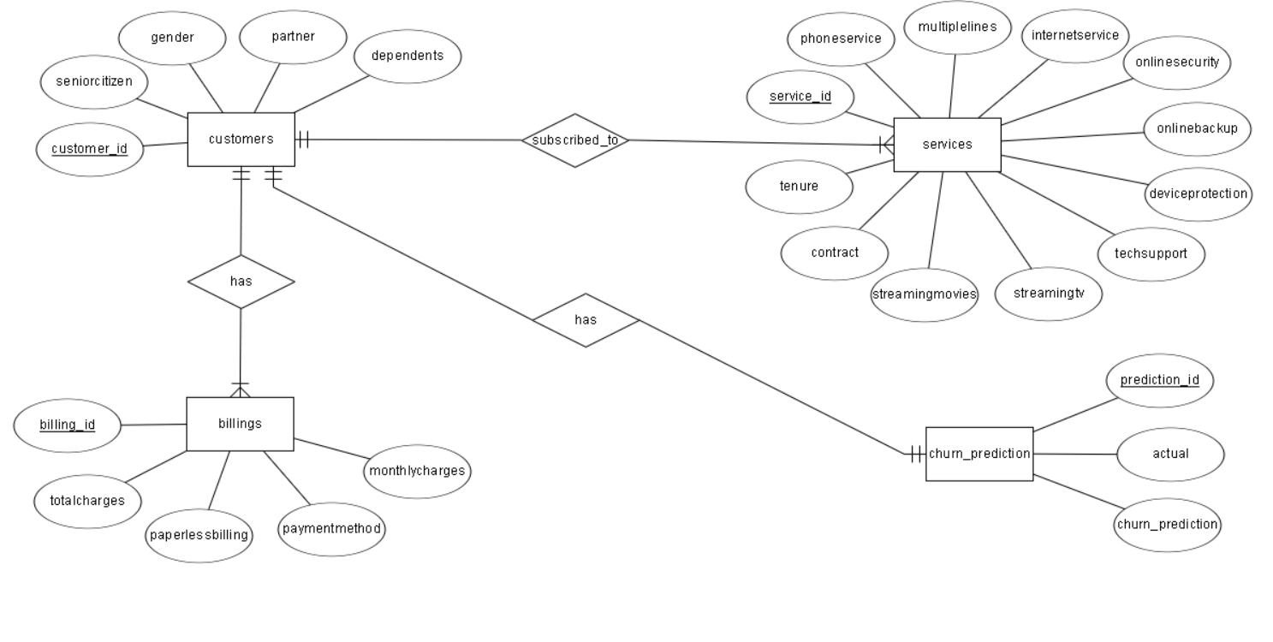

**Relational Schema:**

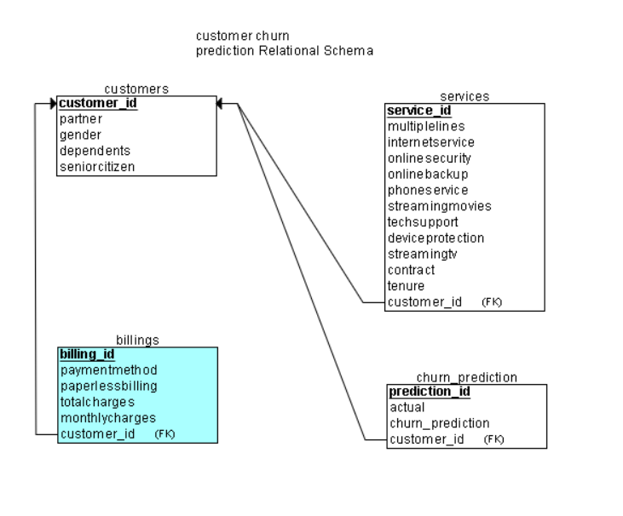

**Creation of database and tables through sql queries:**

-- creating the database for customer churn prediction

create database customer_churn;

-- using that database

use customer_churn;

CREATE TABLE customers (

customer_id VARCHAR(50) NOT NULL,

partner ENUM('No', 'Yes') NOT NULL,

gender ENUM('Male', 'Female') NOT NULL,

dependents ENUM('No', 'Yes') NOT NULL,

seniorcitizen ENUM('No', 'Yes') NOT NULL,

PRIMARY KEY (customer_id)

);

CREATE TABLE services (

service_id INT NOT NULL AUTO_INCREMENT,

multiplelines ENUM('No', 'Yes', 'No phone service') NOT NULL,

internetservice ENUM('Fiber optic', 'DSL', 'No') NOT NULL,

onlinesecurity ENUM('No', 'Yes', 'No internet service') NOT NULL,

onlinebackup ENUM('No', 'Yes', 'No internet service') NOT NULL,

phoneservice ENUM('No', 'Yes') NOT NULL,

streamingmovies ENUM('No', 'Yes', 'No internet service') NOT NULL,

techsupport ENUM('No', 'Yes', 'No internet service') NOT NULL,

deviceprotection ENUM('No', 'Yes', 'No internet service') NOT NULL,

streamingtv ENUM('No', 'Yes', 'No internet service') NOT NULL,

contract ENUM('Monthly', 'Yearly') NOT NULL,

tenure INT NOT NULL,

customer_id VARCHAR(50) NOT NULL,

PRIMARY KEY (service_id),

CONSTRAINT fk_services_customer_id FOREIGN KEY (customer_id) REFERENCES customers(customer_id)

);

CREATE TABLE billings (

billing_id INT NOT NULL AUTO_INCREMENT,

paymentmethod ENUM('Electronic check', 'Mailed check', 'Bank transfer (automatic)', 'Credit card (automatic)') NOT NULL,

paperlessbilling ENUM('No', 'Yes') NOT NULL,

totalcharges FLOAT NOT NULL,

monthlycharges FLOAT NOT NULL,

customer_id VARCHAR(50) NOT NULL,

PRIMARY KEY (billing_id),

CONSTRAINT fk_billings_customer_id FOREIGN KEY (customer_id) REFERENCES customers(customer_id)

);

CREATE TABLE churn_prediction (

prediction_id INT NOT NULL AUTO_INCREMENT,

actual BIT NOT NULL,

churn_prediction BIT NOT NULL,

customer_id VARCHAR(50) NOT NULL,

PRIMARY KEY (prediction_id),

CONSTRAINT fk_churn_prediction_customer_id FOREIGN KEY (customer_id) REFERENCES customers(customer_id)

);

**Data Ingestion:**

**Creating a Connection:**

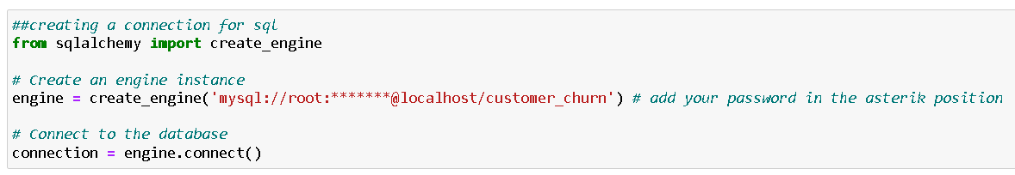

**Inserting data in to Customers table:**

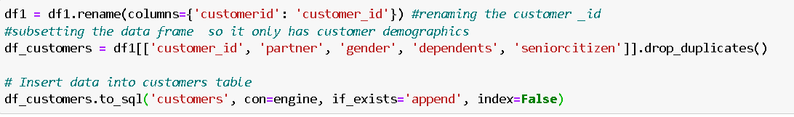

**Verifying through sql:**

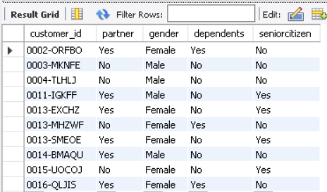

**Inserting data in to Services table:**

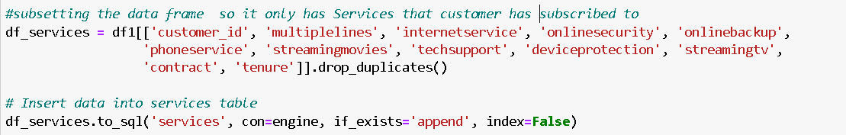

**Verifying through sql:**

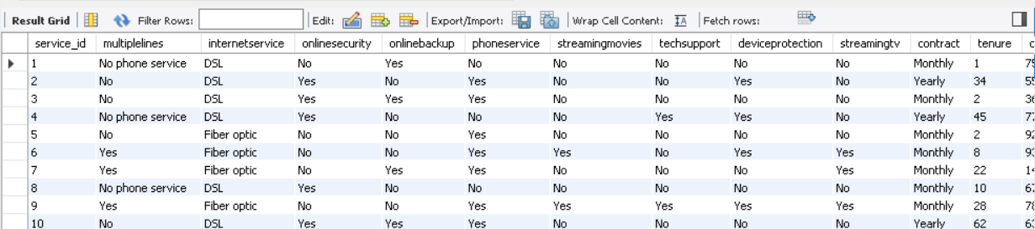

**Inserting data in to billings table:**

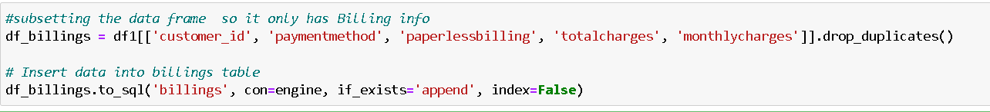

**Verifying through sql:**

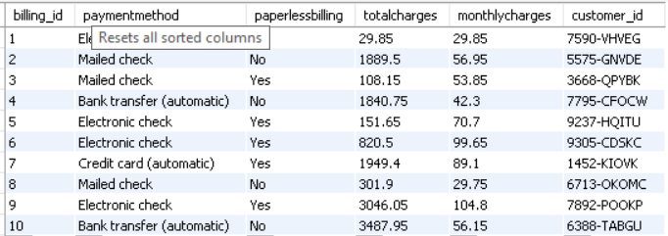

**Inserting data in to prediction table:**

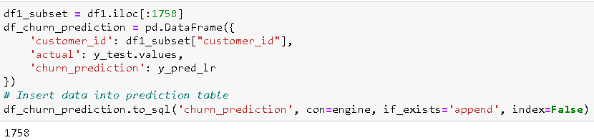

**Verifying through sql:**

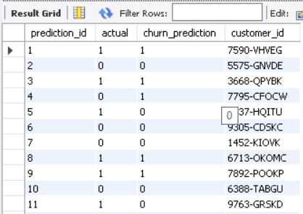

**Querying through Data :**

**-- finding out the total number of customers**

select count(*) as total_customers from customers;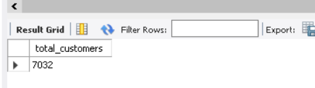

**-- finding out the average tenure**

select avg(tenure) as avg_tenure from services;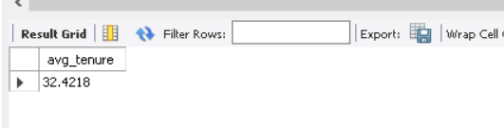

**-- finding out the total revenue**

select sum(totalcharges) as total_revenue from billings;

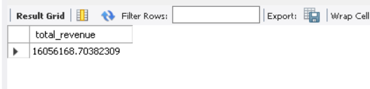

**-- displaying customers that have a yearly contract**

select gender,partner ,tenure,contract

from customers c

inner join services s

on c.customer_id=s.customer_id

where contract="Yearly";

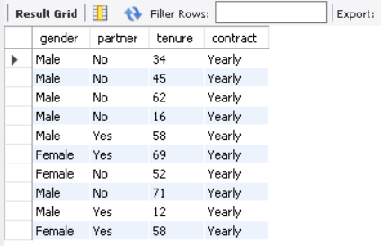

**-- Displaying customers with the equal total and monthly charges**

select customer_id,totalcharges,monthlycharges from

billings where monthlycharges = totalcharges;

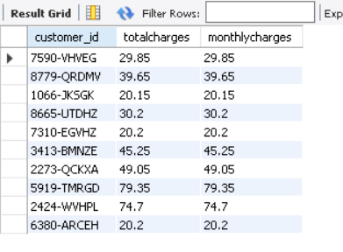

**-- Displaying customers with the monthly charges greater than $70**

select customer_id,paymentmethod ,monthlycharges from

billings where monthlycharges >70.0;

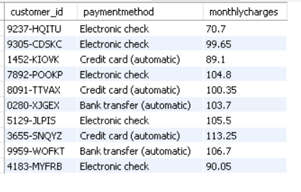

**Advanced SQL Analysis:**

**-- Calulcating the cummulative sum of total charges**

select customer_id, totalcharges,

sum(totalcharges) over (order by billing_id) as running_total

from billings;

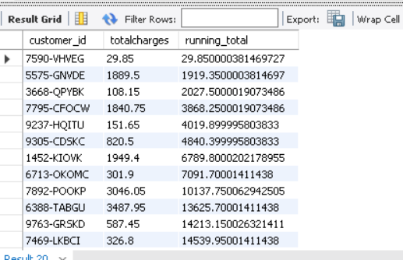

**-- Displaying average of monthly charges over last 5 months**

select customer_id, monthlycharges,

avg(monthlycharges) over (order by billing_id rows between 5 preceding and current row) as moving_average

from billings;

